**Develop the python script**

|  |  |
| --- | --- |
| Assignment Date | 15 November 2022 |
| Team ID | PNT2022TMID19505 |
| Project Name | IOT based child safety Gadget monitoring and notification |
| Maximum Marks | 4 Marks |

Import pandas as pd

Import numpy as np

Import matplotlib.pyplot as plt

From PIL import Image, ImageDraw

Data_path = ‘data.csv’

Data = pd.read_csv(data_path, names=[‘LATITUDE’, ‘LONGITUDE’], sep=’,’)

Gps_data = tuple(zip(data[‘LATITUDE’].values, data[‘LONGITUDE’].values))

Image = Image.open(‘map.png’, ‘r’) # Load map image.

Img_points = []

For d in gps_data:

X1, y1 = scale_to_img(d, (image.size[0], image.size[1])) # Convert GPS coordinates to image coordinates.

Img_points.append((x1, y1))

Draw = ImageDraw.Draw(image)

Draw.line(img_points, fill=(255, 0, 0), width=2) # Draw converted records to the map image.

Image.save(‘resultMap.png’)

X_ticks = map(lambda x: round(x, 4), np.linspace(lon1, lon2, num=7))

Y_ticks = map(lambda x: round(x, 4), np.linspace(lat1, lat2, num=8))

Y_ticks = sorted(y_ticks, reverse=True) # y ticks must be reversed due to conversion to image coordinates.

Fig, axis1 = plt.subplots(figsize=(10, 10))

Axis1.imshow(plt.imread(‘resultMap.png’)) # Load the image to matplotlib plot.

Axis1.set_xlabel(‘Longitude’)

Axis1.set_ylabel(‘Latitude’)

Axis1.set_xticklabels(x_ticks)

Axis1.set_yticklabels(y_ticks)

Axis1.grid()

Plt.show()

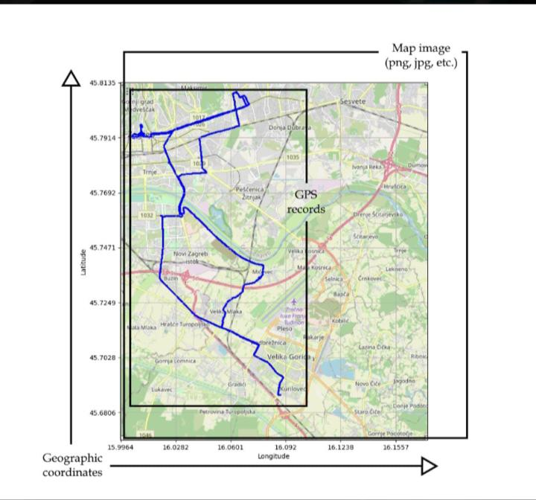

The final result of GPS visualisation